What is OpenCL?
OpenCL( Open Computing Language) is a royalty-free framework that is used for writing programs that can be executed across heterogenous platforms that can consist of GPU( Graphics Processing Units), CPU(Central Processing Units) and other types of processors. To make it an accessible technology, OpenCL includes a programming language, which is based on C99 standards for writing kernels, and an API which helps query, define and control various platforms.
The main components when setting up an OpenCL execution are the following:
Platform: The host device and the collection of devices that can be managed by OpenCL that allow an application to execute kernels and share resources on devices in the platform.
Device: A device is a hardware unit on which OpenCL can execute kernels. A device can be a CPU or a GPU. The Host device, from which the OpenCL is set up can also be used as a device to execute kernels on.
Command Queue: A command queue is an object which holds commands that are to be executed on a specific device. It can be in-order or out-of-order(not all devices support out-of-order command queues).
Kernel: A kernel is an OpenCL specific function that is declared in a program and can be executed on an OpenCL device. The kernels inside a program are identified using the __kernel qualifier.
Program: The OpenCL program is a set of kernels and constant data. We can extract kernels from an OpenCL program.
Context: The OpenCL context defines the devices in which OpenCL kernels are executed and the domain in which memory management and synchronization are defined. The context is made up of a set of devices, the memory that is accessible to those devices, their memory properties and on or more command queues that are used to schedule the execution of kernels.
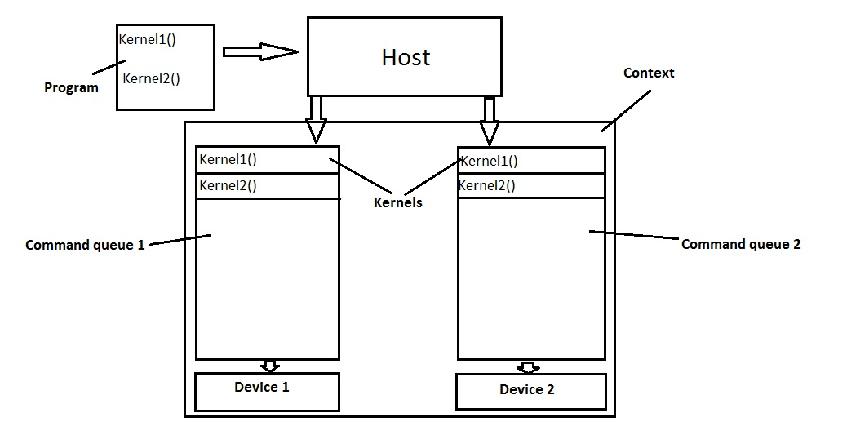

Types of parallelism available in OpenCL:
OpenCL offers two types of parallelism:
Data-parallel execution:
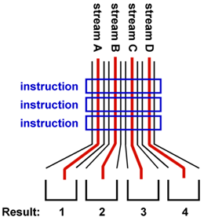
Data parallel execution allows each device to receive the same instructions and operate it over different sets of data.

Task-Parallel execution:
Task parallel execution allows each device to receive different instruction and operate it over different sets of data.
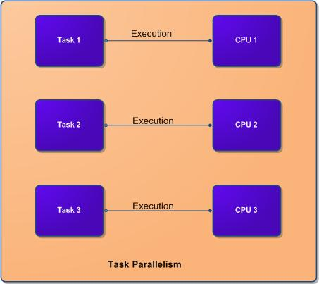

Main Concepts in OpenCL:
Application: An OpenCL application is the combination of a program that runs on the host and the OpenCL devices.
Command: The command is an OpenCL operation that is submitted to an OpenCL command queue for execution.
Concurrency: It is a property of a system through which a set of tasks or commands can remain active and make progress at the same time. This is implemented via threads in OpenCL and the programmer must identify the potential for concurreny in their specific task and implement it in the source code.
Global ID: It is used to identify each and every work-item(thread) that is running, this is derived from the number of work-items when executing a kernel. The numbering of the Global ID starts from 0 to N-1, where N is the number of work-items.
Global Memory: It is a memory region that is accessible to all work-items in a context, it is accessible to the host using commands such as read, write and map. The speed of this type of memory is usually the slowest.
Host: The host is the device( usually the CPU), from which the kernels are launched. It interacts with the context via the OpenCL API.
Local ID: A local ID is one of many work-items inside a work-group that is executing a specific kernel. The numbering of the local ID is analogous with the numbering scheme of the Global ID.
Local Memory: It is a memory region which is associated with a work-group and only work-items from that specific work-group can read or write to it.
Private Memory: It is a memory region which is associated strictly with a work-item, its contents are not visible to other work-items.
SIMD: Single Instruction Multiple Data, it is a programming model in which a given set of instructions, in the case of OpenCL a kernel is executed concurrently on multiple processing elements, each with its own set of data. An important note is that all procesing elements execute the same instruction.
MIMD:Multiple Instructions Multiple Data, it is a programming model in which given sets of instructions, in the case of OpenCL a kernel is executed concurrently on multiple processing elements, each with its own set of data. Each processing element may execute a different instructions.
Work-Item: It is a thread that can be executed by one or more processing elements as part of a work-group which is executed on a compute unit. A work-item can be uniquely identified via the Local and Global IDs.
